Addition Board Games
Adding 0 and 1  Play this board game to practice adding 0 and 1 to a number.  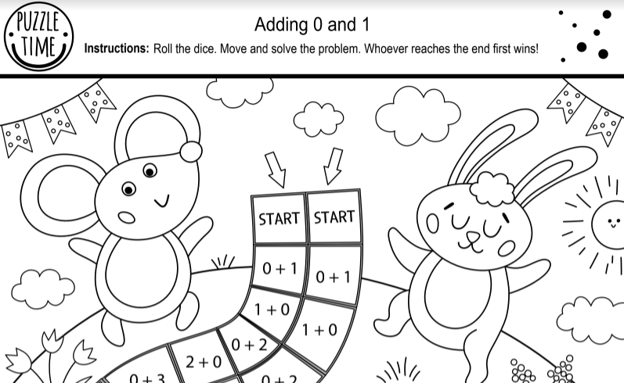 | Adding 1 to a number  Play this board game to practice adding 1 to a number.  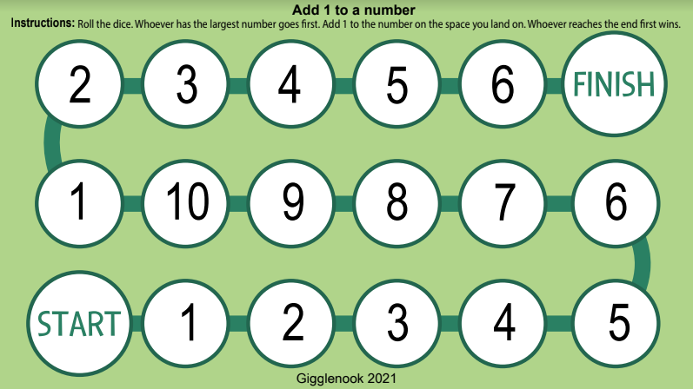 | Adding 2 to a number  Play this board game to practice adding 2 to a number.  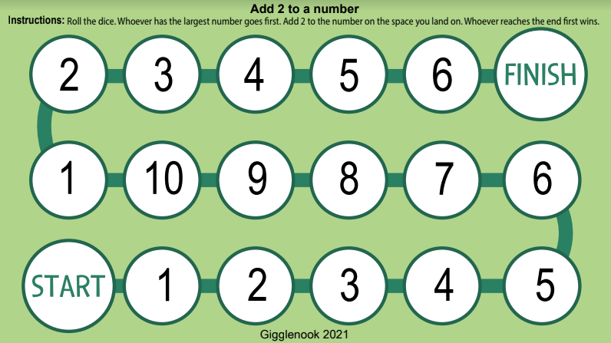
Adding 3 to a number  Play this board game to practice adding 3 to a number.  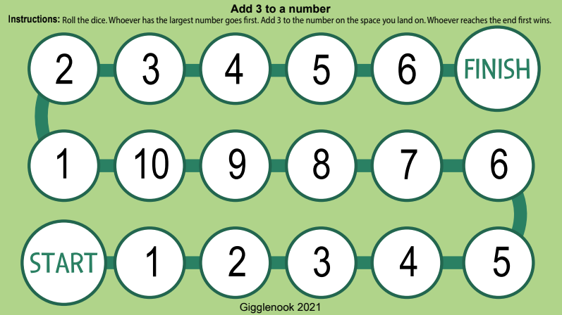 | Adding within 5  Play this board game to practice adding numbers within 5.  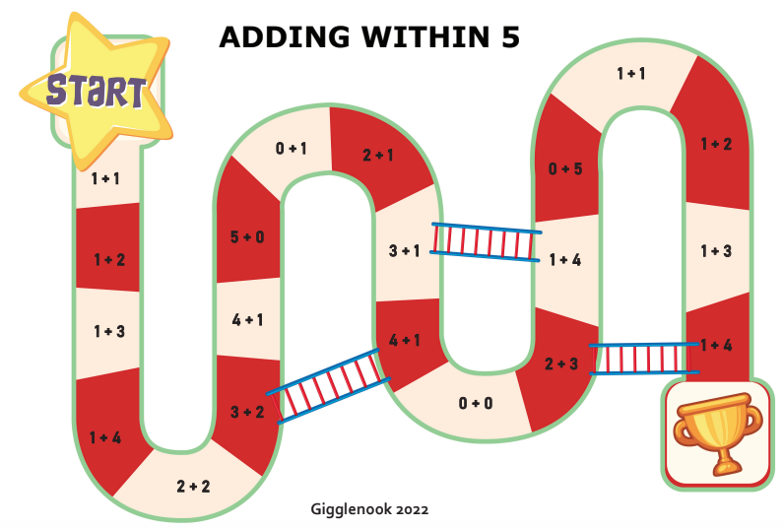 | Adding within 10  Play this board game to practice adding numbers within 10.  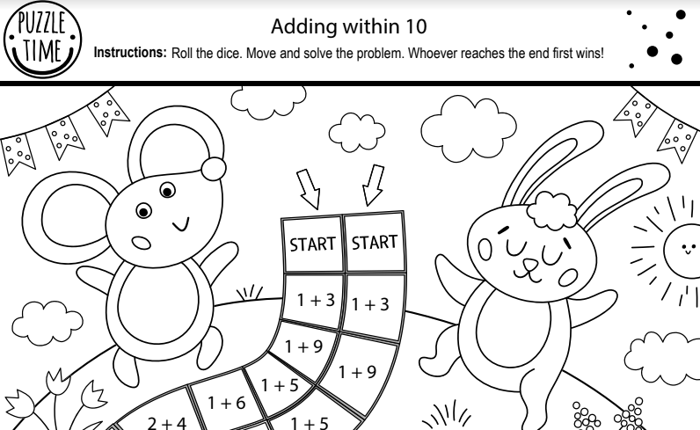
Count on facts  Play this board game to practice counting on facts.  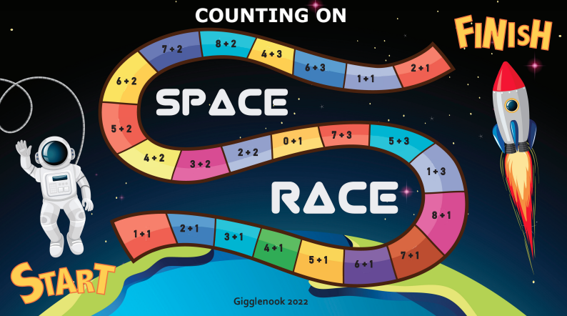 | Doubles  Play this board game to practice adding doubles facts.  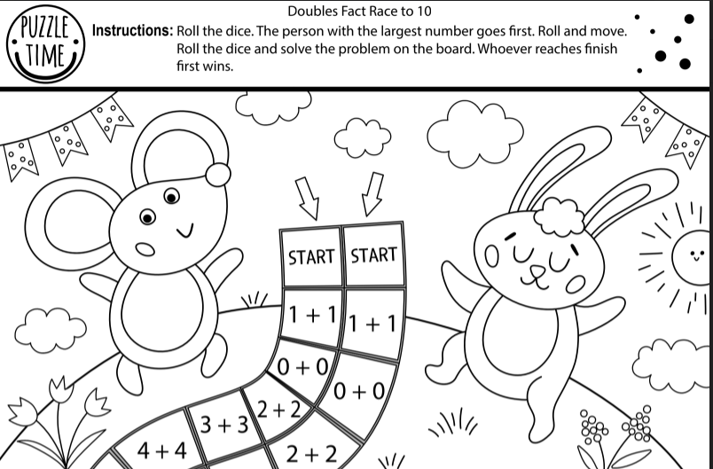 | Working with 1  Play this board game to practice working with the number 1.  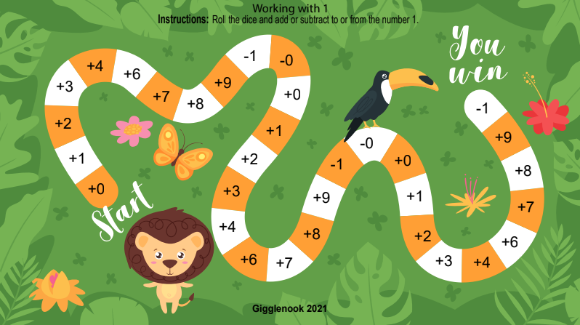
Working with 2  Play this board game to practice working with the number 2.  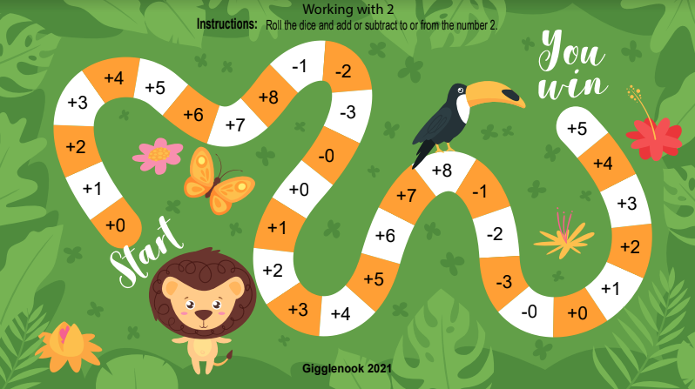 | Working with 4  Play this board game to practice working with the number 4.  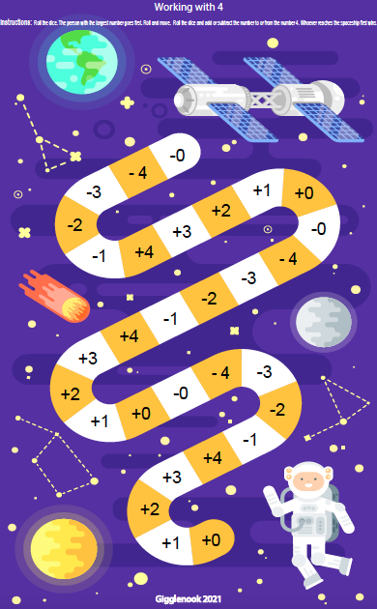 | Working with 5  Play this board game to practice working with the number 5.  