1.The user may be confused at for free, Individual and School login as in landing page after login we can not see any related title for the same
2. Can see error massage after click on “Get started” on school license quote
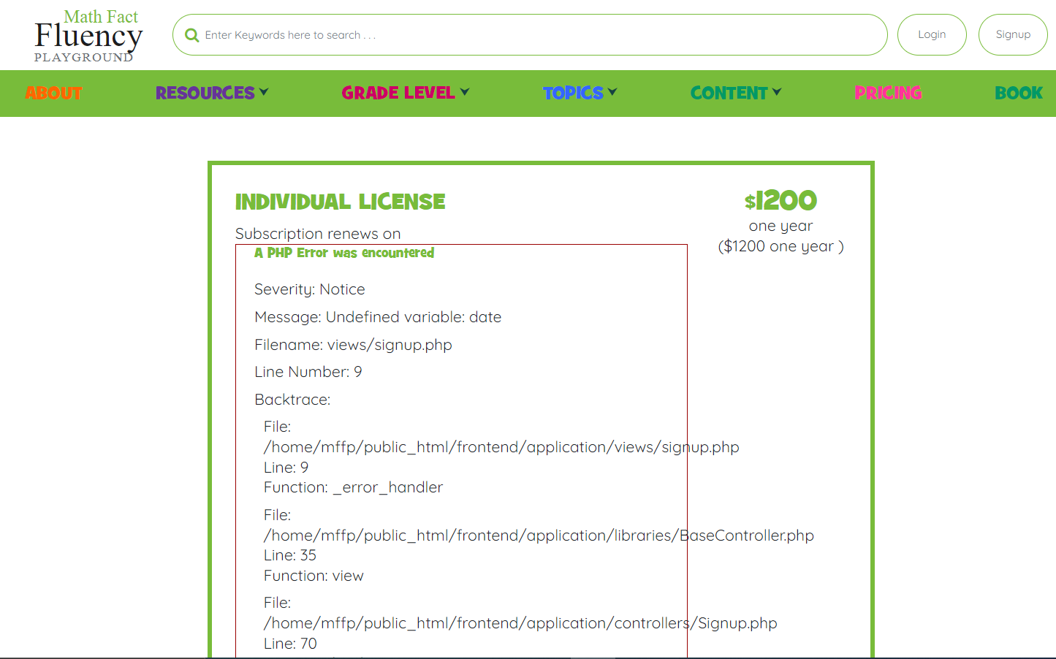

3.I am not getting any proper error massage if I enter wrong password in any login page. See if it can be replicate.
4. Can not see dashboard option clearly. Also can see the page is slightly moving upside down after click on that, but it’s an intermittent issue so its of low priority.
