Multiplication Flashcards
Area Model  These flashcards help students to visualize multiplying with an area model. They can see the partial products. They should explain the model before stating the product.  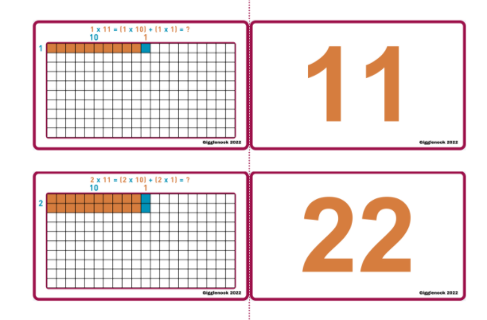 | Array Flip Dots  Great cards to see and understand the commutative property.  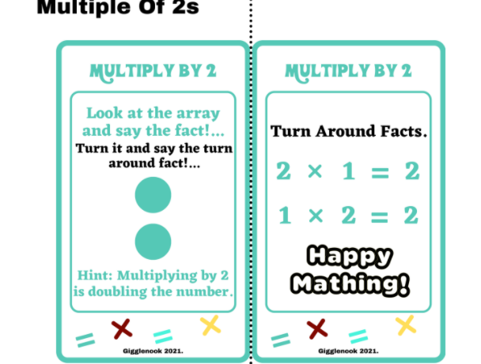 | Array Flip Squares  Use these cards to visualize and explore square numbers.  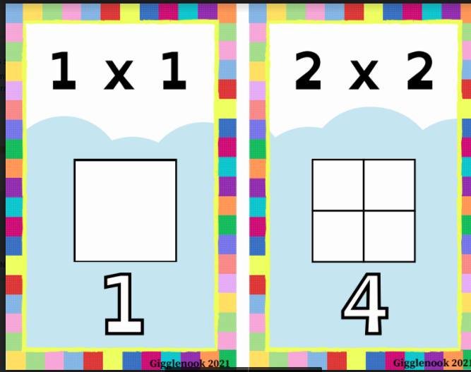 | Array Fuzzy Monsters  Use these cards to visualize and explore multiplication arrays.  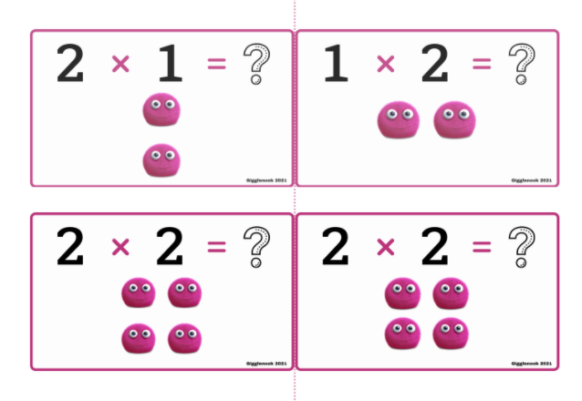
Balance Puzzles  Think about and arrange the numbers so that they balance.  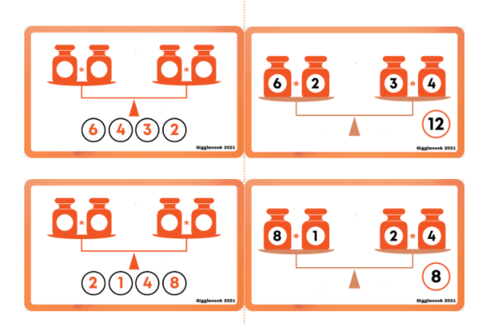 | Blank Puzzles | Concentration Game  This is a concentration game! Students have to match the cards that go together for each fact!  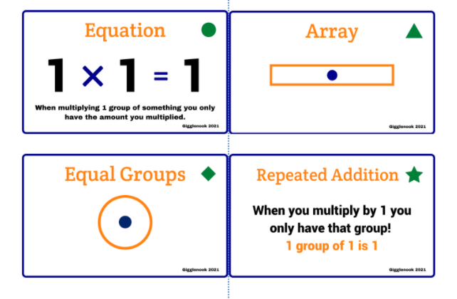 | Dice  These cards visually scaffold the facts with dice. They also help students to see the commutative property.  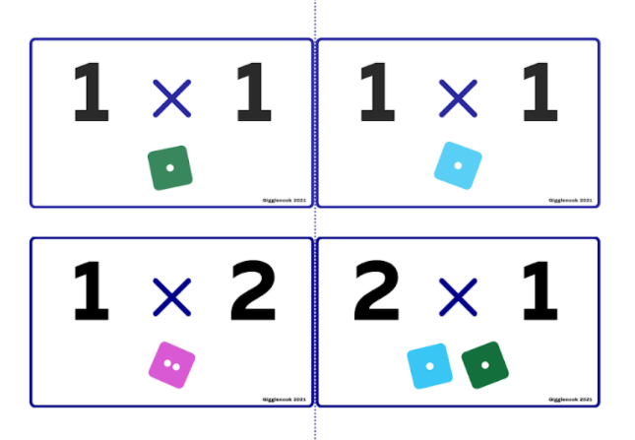
Distributive Property  These cards help students to visualize the commutative property.  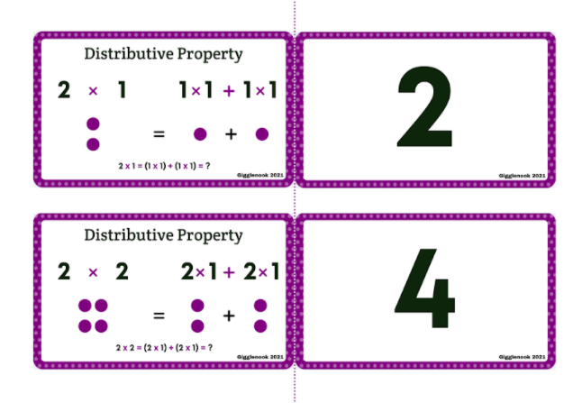 | Equal Groups/Array  Use these cards to practice multiplication with equal groups and arrays.  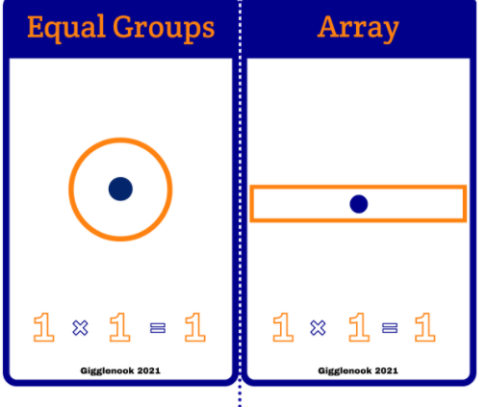 | Even/Odd  Use these cards to explore the relationship between multiplying even and odd numbers.  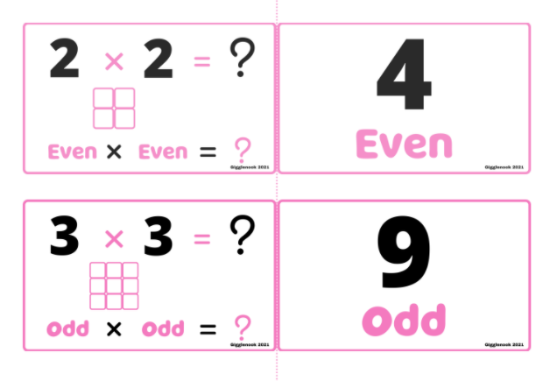 | Clip Cards  Use these flashcards to practice multiplying numbers by 0-12  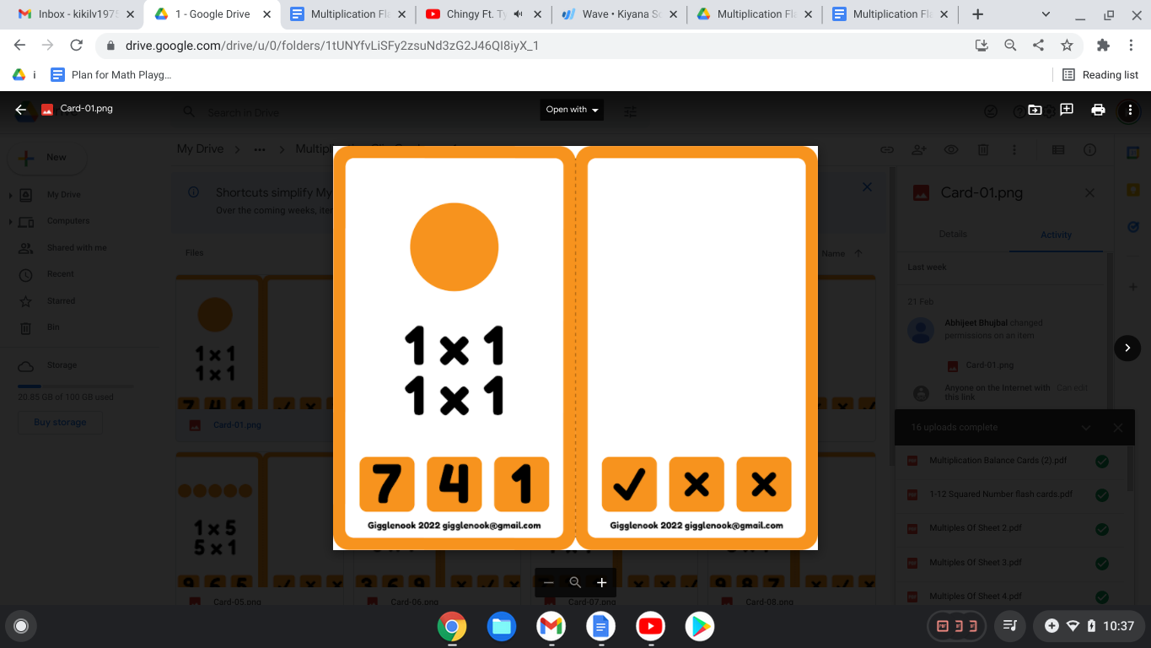
Skip Count Cards  Use these cards to practice skip counting with pictures.  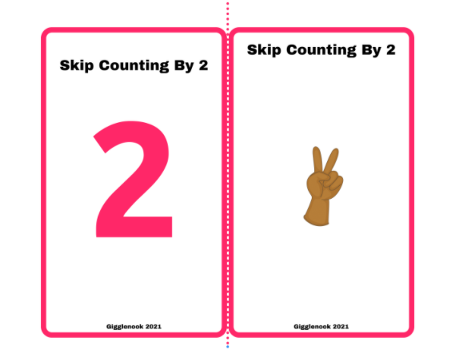 | Vertical  These flashcards are good for practicing instant recall after students have worked concretely and pictorially with the concepts.  