Addition Flashcards
Balance Puzzle  Think about and arrange the numbers so that they balance.  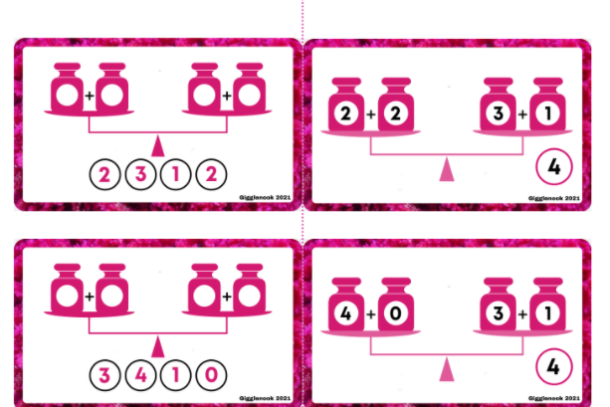 | Blank Puzzle  Make up your own addition puzzles with the students.  