Division Flashcards
Balance Puzzles  Think about and arrange the numbers so that they balance  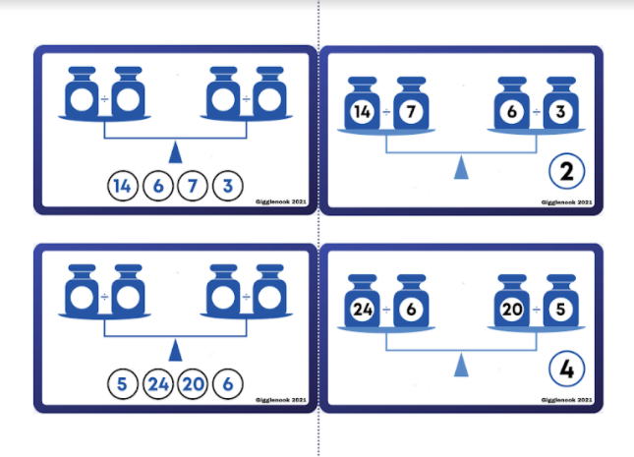 | Missing Operation Cards  Mix these cards with others so that students can reason about which operation they need.  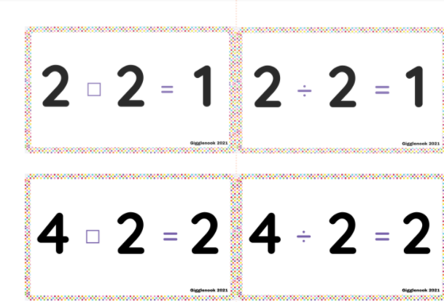 | Dividing with Kids  Flashcards that help students to visualize the division fact.  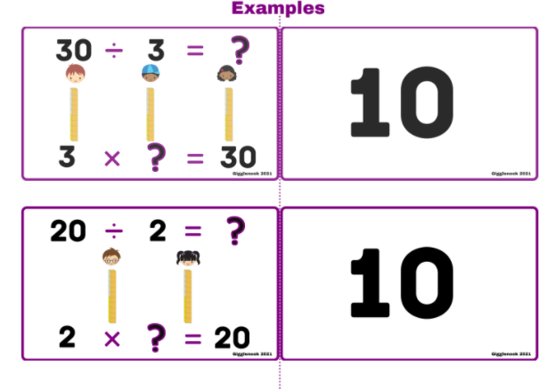
Equal Groups  These flashcards help students to see the different types of division.  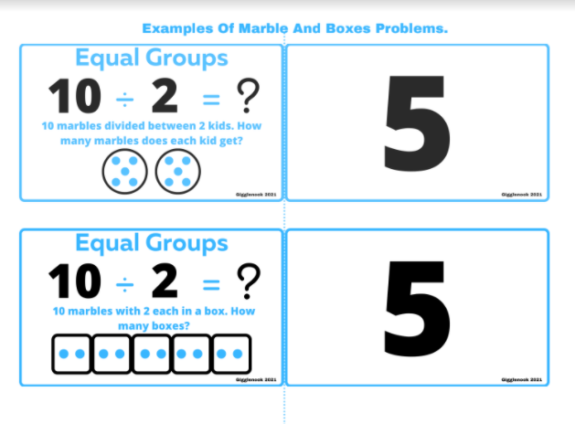 | Fact Family  These flashcards help students to see the relationships between multiplication and division.  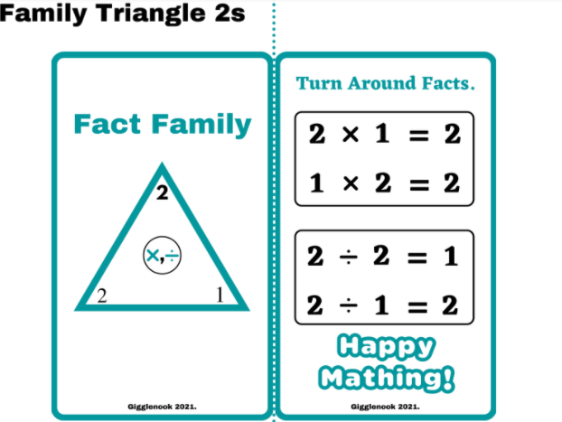 | Visual  These fun clip cards help students to practice their division facts.  