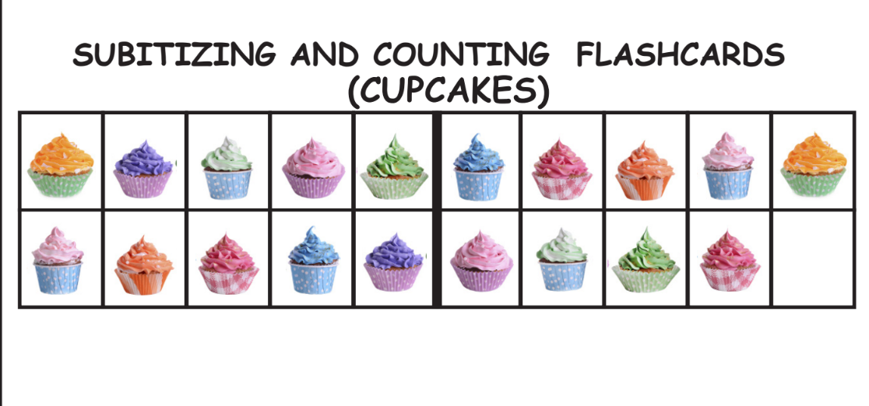Fantastic Flashcards for practicing numbers to 20. Students should focus on looking at ten and some more!

